Adelaide Moulding and Casting Supplies
9 Vincent Avenue
Somerton Park SA 5044
Australia
www.amcsupplies.com.au

TECHNICAL DATASHEET

Chromatic Dental Alginate
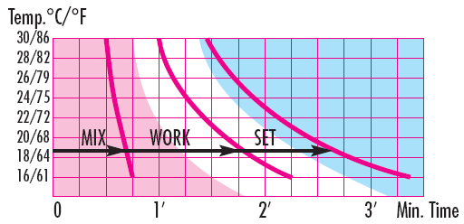
ISO 1563 / ADA 18 Fast setting
• Setting time: 2’00” (at 23°C)
• Four colour changing stages
• Dust-free material
• Excellent biocompatibility
• Lead and cadmium free
• Snap setting
• Easy mixing
• Five days pour-up time (if properly sealed)

Instruction:
Shake appropriately the package to make the contents uniform.
Dosage: 2 powder measures (19g) and 2 water measures (40ml) for a complete impression. Spatulate energically.
Mixing Time: 35” (showed by the fuchsia chromatic phase).
Fill up rapidly the tray. Insert the tray in the mouth
Working Time: 1’20” from the beginning of mixing (showed by the white chromatic phase).
Setting Time: 2’00” from the beginning of mixing (noted by the pale sky-blue final colour).
Time values indicated are applicable operating at room temperature of 23°C (73°F), using water at 23°C (73°F). Temperature or water hardness variations involve variations in the working time and in the total setting time (see Temp-Time diagram). The impression should be cleaned of saliva and debris and poured immediately after cleaning so that the most accurate results are obtained.
Otherwise keep the impression in a humid environment to avoid water evaporation. Do not keep the impression into water. Preserve the products in sealed bags and in a dry and cool place. During the use, always close the container.
Compatible plasters:
Type: 3 (KERR Hydrocal)
Type: 4 (WHIP MIX Prima Rock)
CAUTION
• Do not breathe in alginate dust.
• Use in a well ventilated area.
• Use of a mask to avoid exposure is recommended.

